**Experiment -2.4**

**Student Name: Sandhya Kumari UID: 22BDO10074**

**Branch: CSE(DevOps) Section/Group: 22BCD-1/B**

**Semester: 4th Date of Performance: 06/03/24**

**Subject Name: Git and GitHub Subject Code: 22CHS-293**

1. **Aim/Overview of the practical:** Git merge conflicts and resolving git merge conflicts
2. **Task to be done:** - Merge Conflicts
3. **Steps for experiment/practical:**

**1.Clone a repository:** Colne a repositor from remote to local system and move inside it.

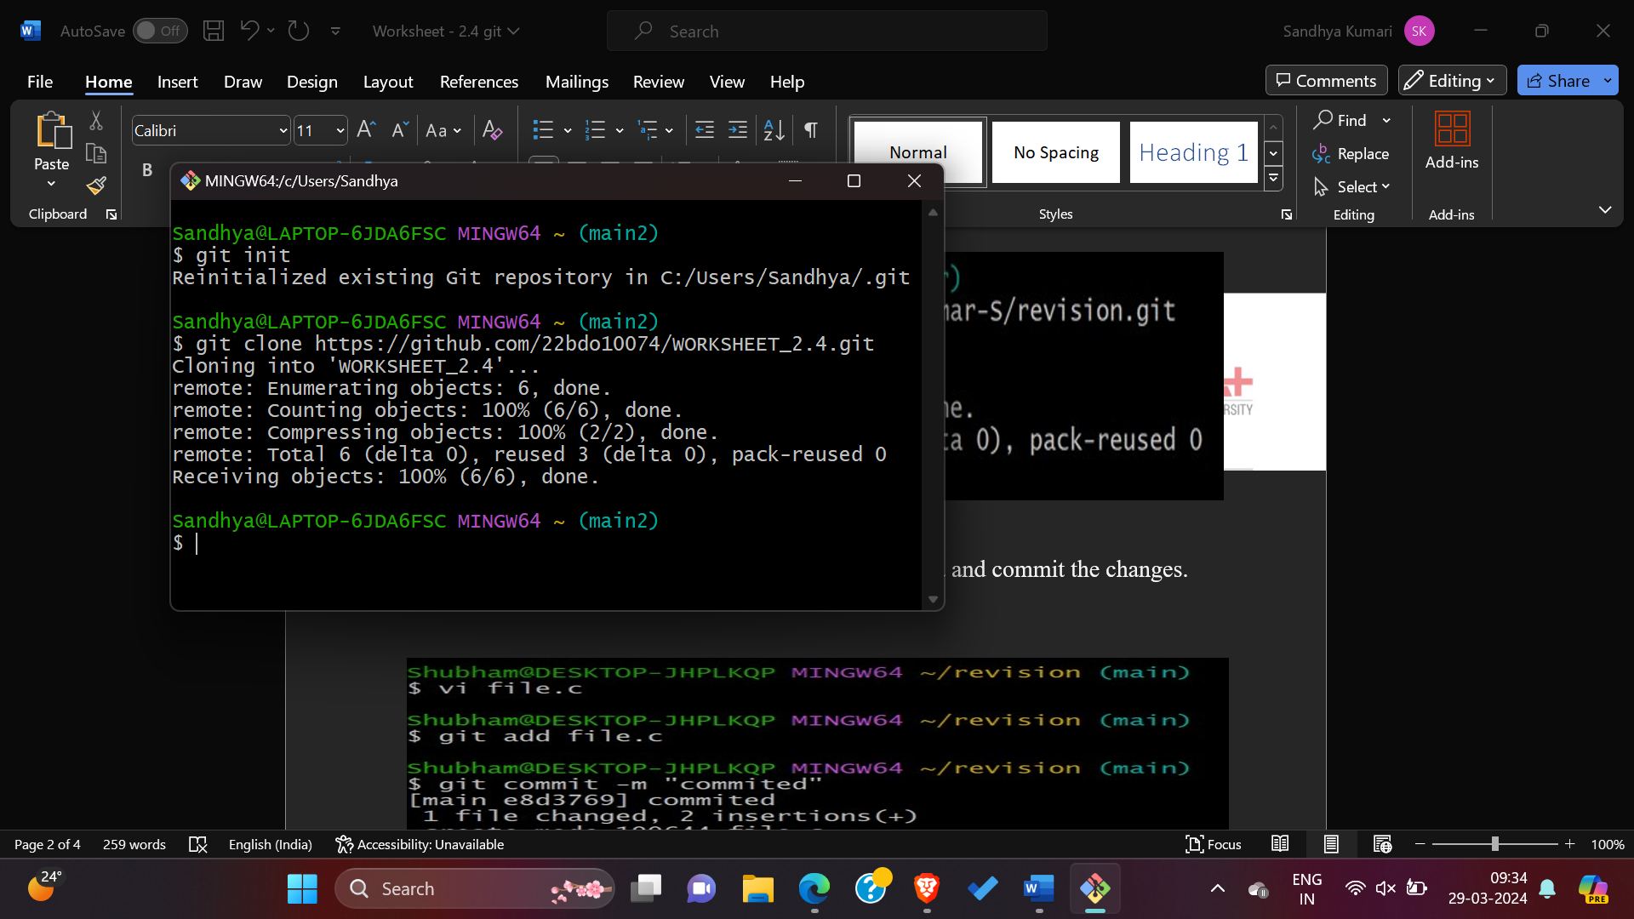

* 1. Create a file in the local system, add it to the staging area and commit the changes.

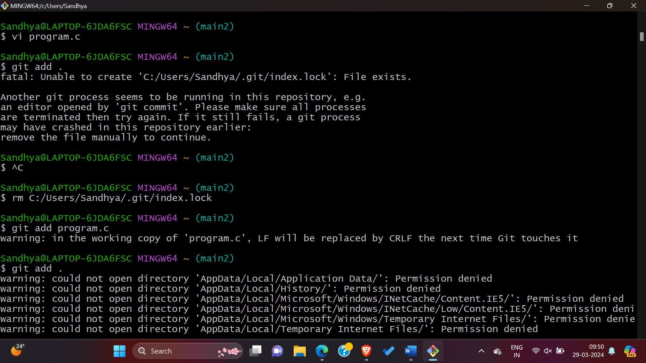

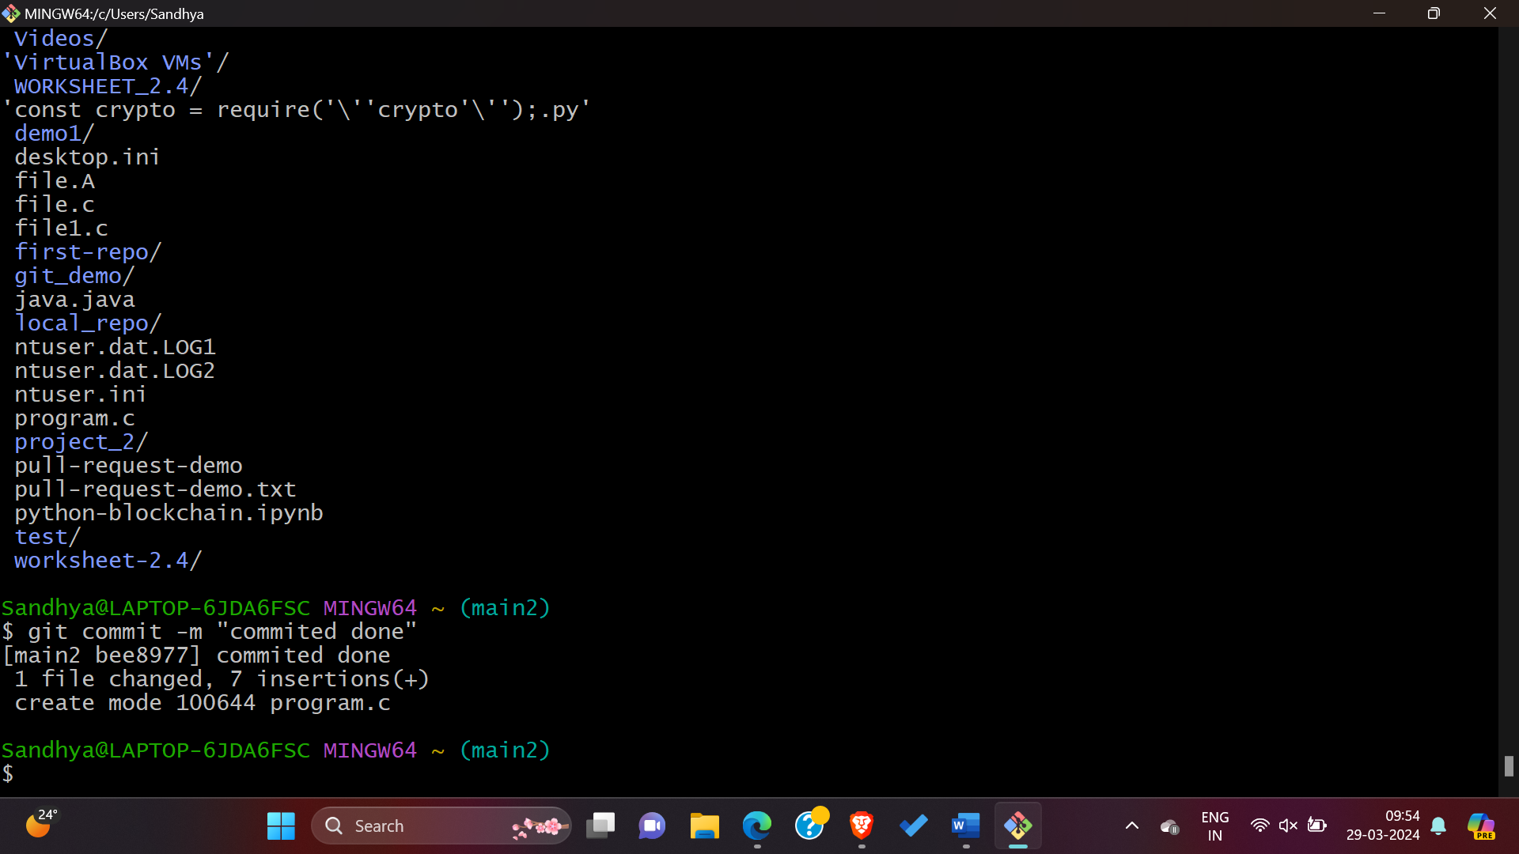

* 1. Checkout to the main branch and merge the changes using the git merge command and **- - no - ff** operator.

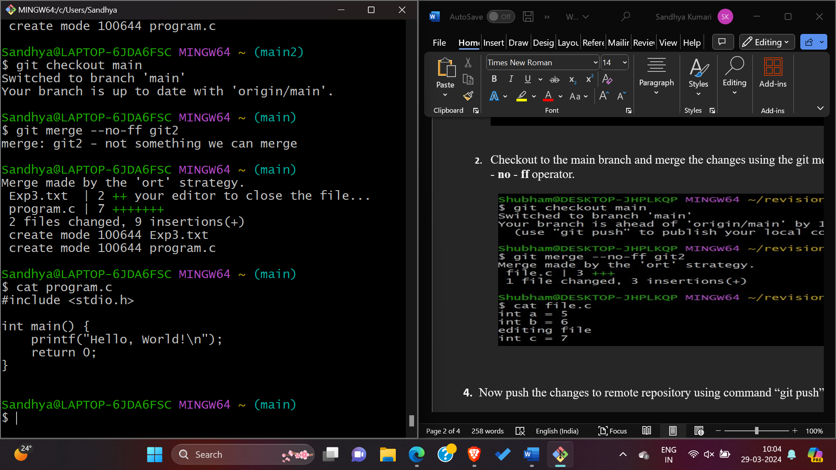

3. Now push the changes to remote repository using command “git push”.

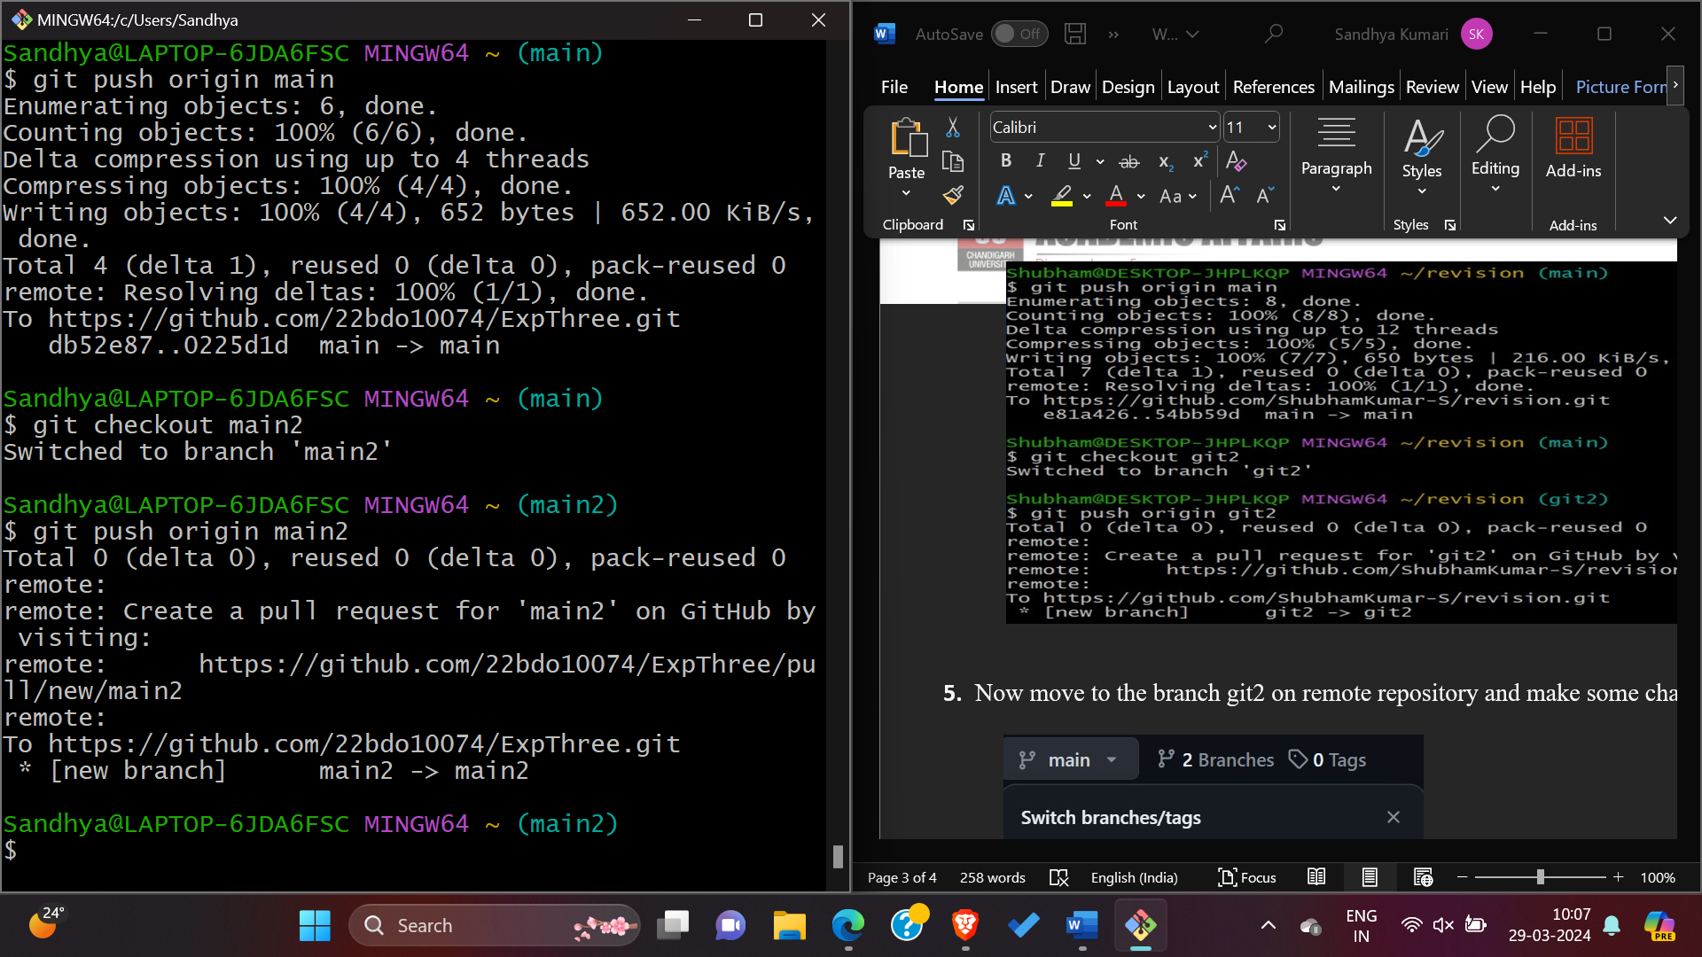

5.Now move to the branch main2 on remote repository and make some changes and commit it.

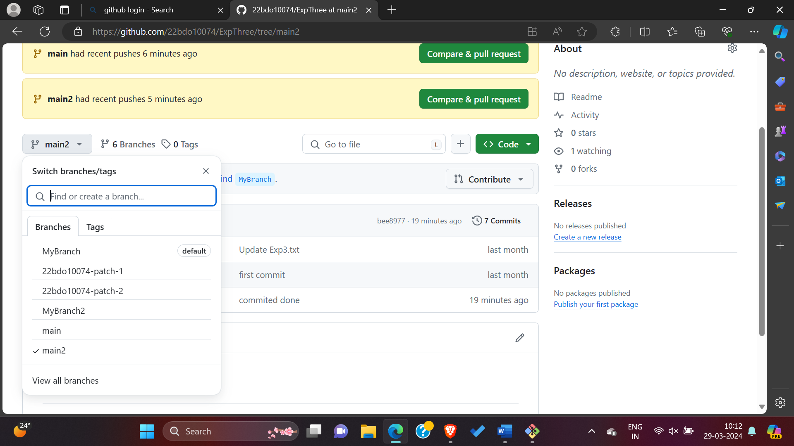

6.After merge the pull request and confirm merge request, Now you can see the changes in the main branch.

**4. Result/Output/Writing Summary:**

In this experiment, we have merged a file in a branch to the master or main branch on both the local as well as remote repository.

**Learning outcomes (What I have learnt):**

1. Learnt about cloning of repository.
2. Learnt how to create a branch
3. Learnt how to create a pull request and handle their merging.
4. Learnt how to clone a remote repository to our local system.

**5.**Learnt how to resolve merge conflicts.

**Evaluation Grid (To be created as per the SOP and Assessment guidelines by the faculty):**

|  |  |  |  |
| --- | --- | --- | --- |
| Sr. No. | Parameters | Marks Obtained | Maximum Marks |
| 1. |  |  |  |
| 2. |  |  |  |
| 3. |  |  |  |
|  |  |  |  |